2 Minute Form
Trip Name: Moturekareka and Motuketekete Islands
Check-in Name and Phone:
Date: Branch:
Leaders
Cell Phone Number
VHF Call Sign &/or Vessel Name
Vehicle make, model, registration, colour
General Plan
Note: If plan changes, you must notify your Check-in person.
Latest Time Off the Water |  |  |  |  | TMP used²⁰
Tide/ Forecast Lake Level | Low |  |  | High | Other
Communications Carried²¹
Communications | We will be communicating as a group on VHF Channel _____
Equipment Carried
Trip Report
(Use other side if more space required)

Activity | Club trip | Centre | Auckland | Location |  |  | Auckland |  | Difficulty¹ |  |  | Intermediate, or strong beginners if conditions are suitable.
Activity Description | Launch at Martin’s Bay and paddle out to and circumnavigate Moturekareka and Motuketekete Islands. |  |  |  | Leader qualification req.² |  | Trip leader
Get in Location | Martin’s Bay |  |  |  | Chart/ Map no.⁴ |  | 532 |  | Distance |  |  | 15km total
Get out Location | Martin’s Bay |  |  |  | Coastguard Channel |  | 82 & 16 |  | Nowcasting |  |  | 21
Emergency get out ⁵ | None |  |  |  | Emergency / Coastguard Station |  | Auckland |  | Phone |  |  | *500  09 303 4303
 |  |  |  |  | Drinking Water⁶ | at Martin’s bay |  | Toilets⁷ |  |  | At Martin’s Bay
Emergency Response | Refer Emergency Response Booklet |  |  |  |  |  |  | Parking⁸ |  |  | At Martin’s Bay
Specific Equipment Required⁹ | Helmets if planning on rock gardening.  High visibility clothing/flags etc |  |  |  | Working Communications equipment in this area¹⁰ | Cell phone  Sat phone |  |  |  | Mountain Radio |  |  | PLB  VHF
Other resources  and notes¹¹ | These are two of the prettiest islands in the region. There are caves on the eastern side and rock gardens; the wreck of the ''Rewa" lies upright in a sheltered bay and it's possible to paddle inside at high tide. This was deliberately sunk as a breakwater. More information below.  Pest free Islands – ensure that kayaks and gear are checked for pests – rodents, Argentine ants, Rainbow skinks, seeds. |  |  |  | Weather Parameters¹² | Beginners Wind under 15 knots, no significant surf or swell  Intermediate Wind under 25 knots, and surf or swell less than 1.5 metres  Advanced Any condition that is suitable for the trip's aims
Previous incidents -

Safety Management¹⁴
Hazard |  | Significant?  - E/I/M |  | Management Strategy¹⁵ |  |  |  | Hazard | Significant?  - E/I/M | Management Strategy¹⁵
Cold Water |  | Yes - M |  | Carry spare dry clothes and shelter |  |  |  | Deep Water | Yes - E | Correctly fit PFDs
Medical Conditions |  | Yes - M |  | - Leader has first aid qualification  - Ask customers about medical conditions |  |  |  | Bad Weather | Yes - M | Understand weather forecasts.  Have back up plans or pull out if necessary
Capsizing |  | Yes - M |  | - Correctly fit PFDs  - Skills at performing rescues. |  |  |  | Heat / Sun | Yes - M | - Protective Clothing (worn), Sunglasses, Hat  - Sun Screen  - Plenty of drinks
Panic |  | Yes - M |  | Ensure conditions match level  of skills |  |  |  | Obstacles | Yes - M | Awareness of reefs, navigational hazards, nets
Swell |  | Yes – M |  | There is the potential for ocean swell coming on to the islands – ensure that those participating have the skills required for the conditions on the day, particularly if rock gardening. Wear helmets if appropriate. |  |  |  | Other Vessels | Yes - M | - Understand the “rules of the sea”  - “Be seen” – Have two of the following; flag, brightly coloured kayak, brightly coloured Pfd or hat. At night: an all- round white light & a powerful torch.
Written up by: | Larraine |  | Approved By: |  | Russell Williams | Signed: | RW |  | Date: | 7 May 2014 | Review in: | 12 months from date of approval

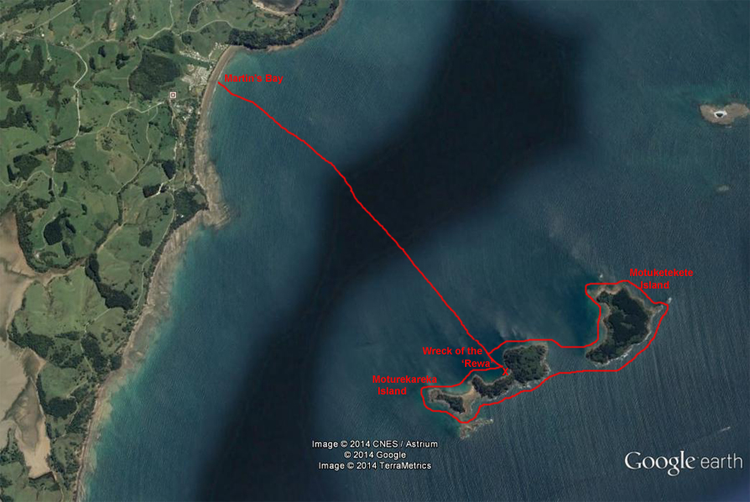
Additional Information Sheet (Optional)
Introduction (A general introduction) |  | There is an interesting history of the wreck of the ‘Rewa’ on Moturekareka Island.  http://www.localmatters.co.nz/Opinion/Columns/History/Warkworth++District+Museum/The+hermit+of+Moturekareka+Island.html
Description (A description of the tour – as if you were selling the idea to someone)
Local Attractions |  | Transport/ Local Operators
 | Contact details |  | Contact details
Local Eateries
 | Contact details
Accommodation/ Campsite Locations |  |  | Facilities
Name |  |  | Cabins |  | Fuel
Phone |  |  | Showers |  | Power
E-mail |  |  | Toilets |  | Water Access
Website |  |  | Laundry |  | Pool
Physical Address |  |  | Water |  | Fires Allowed
Other |  |  | Supplies
Other information

Activity Equipment Check list
Equipment List
- Helmet (rivers & surf) Group Gear
❑ Beanie / hat  Split paddles
❑ Thermals  Repair kit
❑ Paddle Jacket  Fire lighting
❑ PFD  Cooker/thermos
❑ Spray deck  Spare thermals
❑ Booties  Tow system
❑ Water & food  1st Aid Kit
❑ Kayak & paddle  Flares
Group - Oceans & Lakes  Compass
❑ Pumps & Paddle Floats  Charts / Maps
Group - River  GPS (optional)
❑ Throw ropes  Knife (cut rope)
❑ Pin kit & saw  Emergency Shelter

In case of emergency: Dial 111, Mayday :VHF Channel 16

Kayaking Check list

❑ Trip plan
❑ Latest weather forecast
❑ Conditions match skills?
❑ Hyperthermia (hot) &
Hypothermia (cold)
❑ On & off water safety
❑ Environmental concerns
❑ Emergency Procedures include emergency get out.
❑ Working communication devices
e.g. VHF radio, mobile phones, PLB
❑ Specific safety issues for this trip
❑ Participant list
❑ Any medical conditions
❑ All participants keen to proceed?

❑ Trip Plan/ 2-minute form lodged with Ops. Manager

Appropriate wind conditions to run trips:
Novice - no significant surf or swell, wind under 15knots
Intermediate- surf or ocean swells less than 1.5 meter or wind under 25 knots.
Advanced- any condition that is suitable to the trips aims

At conclusion of trip:
Contact check in person
Group Debrief.

Check in Person Ph:
__________________ Mobile
__________________ Work
__________________ Home

Activity Document Cover Sheet

Activity:
Date of Activity:

Activity reports. Is all relevant information present:
– Approved Trip Management Plan (TMP)/ 2 minute form
– Club Trip Participant Sheet
– Weather forecast
– Activity Check List
– Trip report (May be on the 2 minute form)
– Accident / incident reports
Leaders Signature:
Date:

